**D2 – Explain the potential risks to an organisation of committing to an e-commerce system**

**Introduction**

In this report, I will explain the potential risks of payment methods in an e-commerce system. Some examples of payment methods could be electronic cheque, PayPal, NoChex, and credit & debit cards. I am going to explain and describe the payment system. After, I will name the advantage and disadvantage of these payments. I will compare all of these payments with a conclusion.

**Explanation**

**Electronic cheque**

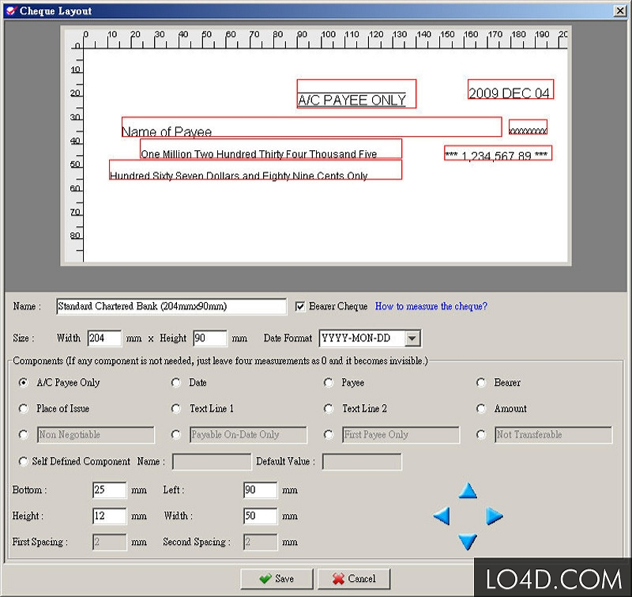This could be sometimes referred as eChecks. An electronic cheque is another way to pay an amount electronically. This works by the customer filling in an ordinary cheque, and then the customer scans it. Scanning it makes an electronic version of it. Once the company checks and approves the cheque to take money, the transaction would be complete. Electronic cheques are popular, and more people are using this.

This image shows an example of an Electronic Cheque. The customer has a choice to write it down before scanning, or type it in electronically.

**PayPal**

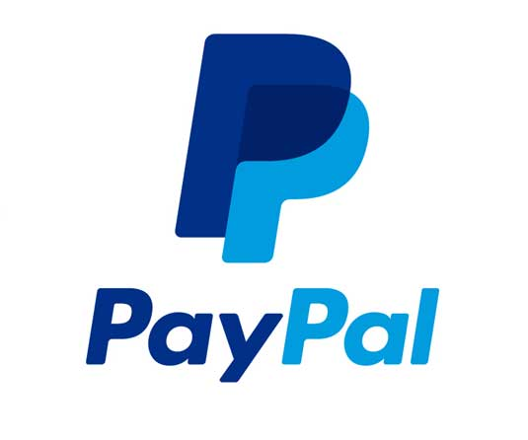PayPal is another way to way of completing transactions. PayPal is an American e-commerce company that allows business to be transferred over this website. This works by the customer linking his or her credit card onto PayPal. By linking it, any user can transfer money to another person’s account. The customer and a company trying to complete a transaction could do this. This works by going on another site to purchase any product. Once you add the product to the basket, it normally says, “How would you like to pay?” For PayPal, you click it. They will transfer you to the site, and you log in to pay. Once the payment is complete, you return to the site. This is very popular.

**NoChex**

NoChex is another online service provider. This one is based in the United Kingdom. This offers a way to pay, generally through credit cards. This works by Nochex dealing with the process of the system. For example, if I were to buy something on eBay, Nochex would if the money is in my account for the process to begin. They not only cater small and medium businesses, but it has been integrated to e-commerce websites too; which include eBay.

They make sure that the transaction is safe, and efficient.

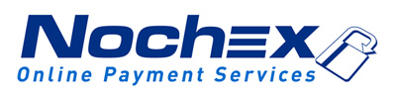

**Credit & debit cards**

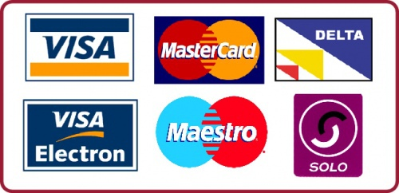Credit and debit cards are a payment card that allows users to purchase anything whilst using that card. A debit card allows you to purchase goods from shops with an option to withdraw cash from it. Credit card enables you to purchase goods up until a pre-arranged limit. This is very clever, because all you need is a pin to enable the purchase.

**Pros and Cons of Payment Systems**

**Electronic cheque**

**Advantage**

* 24 hour access to it
* Easier
* Increased efficient and it saves time

**Disadvantage**

* Takes time to take money off the account
* Takes even longer if the eChecks is rejected, or returned
* Discouraged by banks due to fraud

**PayPal**

**Advantage**

* Security secured
* Saves time
* Saves money – different countries, it converts it to the lowest price for you to enable the process

**Disadvantage**

* Sometimes, PayPal account can be freezed, so the customer cannot use the account. If PayPal felt you committed fraud or anything else, they can use their power to freeze the account
* Charged for using services

**NoChex**

**Advantage**

* Instantly available
* Accepts payments from around the world

**Disadvantage**

* Charged for using services

**Credit & Debit cards**

**Advantage**

* Quick and easy once money is within the account
* You will not be in debt

**Disadvantage**

* If you forget the pin, you cannot use the card
* Block account if pin entered more than three times

**Comparison**

**Credit & Debit Cards vs. PayPal**

The security for payment cards is that you are in hold of the card. If anything is wrong with it, it is your responsibility to fix it. However, if something is wrong with PayPal, you will need to speak to one of the PayPal advisors. PayPal, you can send money all over the world. In addition, conversion of currency is automatically complete. However, credit card takes a longer process to complete. PayPal’s transactions can be complete within an instant. However, the credit cards take a longer process. They will need to put the money in the account and then complete the transaction. However, both obviously require money to be held within the account.

**NoChex vs. Electronic Cheque**

NoChex is available instantly, but cheque takes a very long time to complete. For example, for NoChex, you put in the money within your account and the transaction is complete. For electronic cheque, you have to put scan the cheque and it will take time for the company to receive it with your product being delivered. The only difference between the two is that NoChex charge money for all transactions. An initial fee would be around £1.99. Users that use NoChex have to be warned to put more money to be safe. This is not the case with the electronic cheque. Electronic cheque is not charged.

**PayPal vs. NoChex**

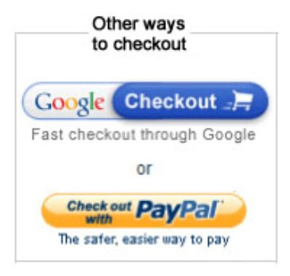They are both similar in the way it works. They both charge similarly for all transactions. This means, when a user is going to purchase a product, both of these companies charge money on top of that purchase. NoChex is located in United Kingdom, whereas PayPal is located in America. The difference is that not only the location, but assistance. If a user needs help, he can call NoChex straight away. However, PayPal help would take longer than expected. The picture below shows how each of them is used. All you do is click on one of them, and it works.

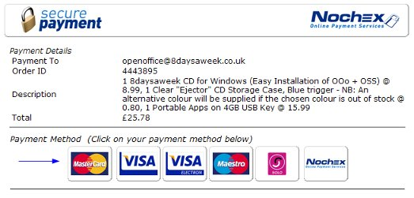

**Popularity for each payment method**

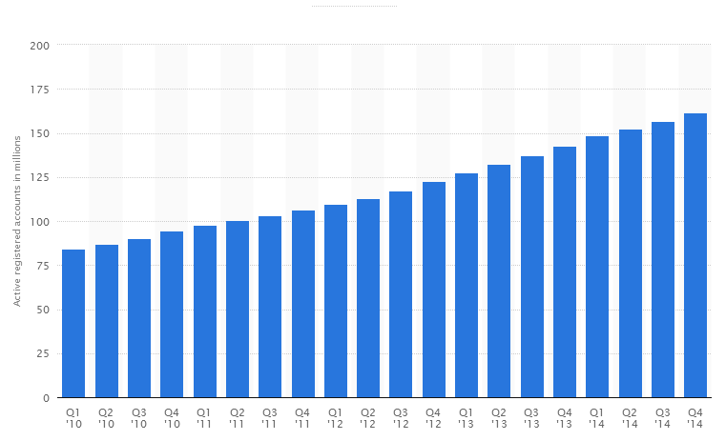

**PayPal –**

**This statistic show that over 161.5 million active users were on in 2014 all over the world**

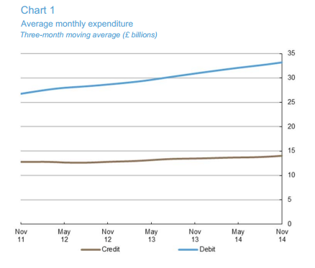

**Credit and Debit Cards used in the UK monthly – This totals to 48.6 billion in November**

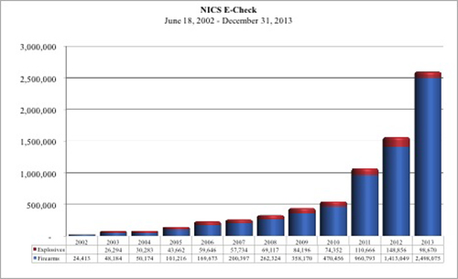

**E-Check stats –**

**Total number of users for E-Check in 2013**

**NoChex stats**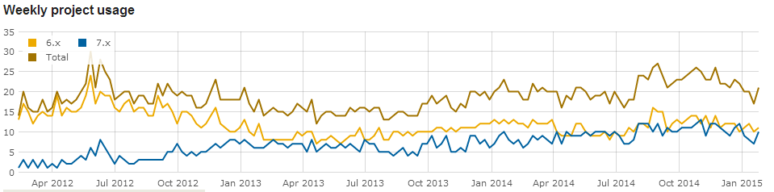

**Conclusion**

In this report, I have learnt the different ways of how an e-commerce website purchases a product. They are many ways in which the customer can pay. I recommend for Tick Tock to use PayPal, and credit and debit cards. This is because it is efficient. The customers know that once they are going to purchase a product, they need to top up their credit card. Tick Tock can use PayPal as an option too.